Test Case: tc002_SPX_Dev5_Crear_Requisicion_Spot_Con_FAD_Tipo_Cobro_CC
Step 1 - Enter username and password and click to button Enter : Credentials Entered
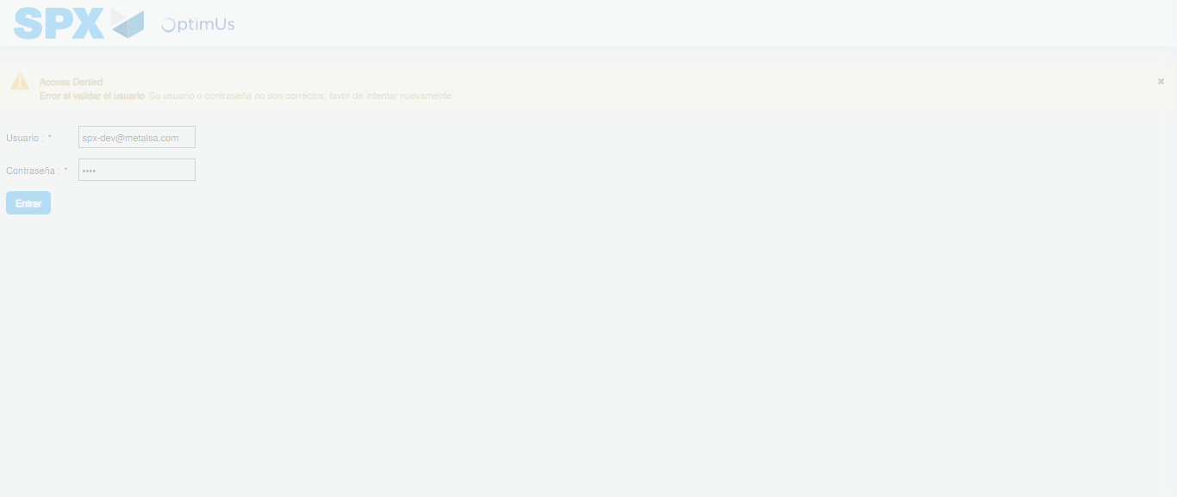Image file-name: QC_Testing-tc002_SPX_Dev5_Crear_Requisicion_Spot_Con_FAD_Tipo_Cobro_CC-1785343141414

Step 2 - Select to UEN and Access to Spot Buy Requisitions : UEN Correctly selected and Correct access
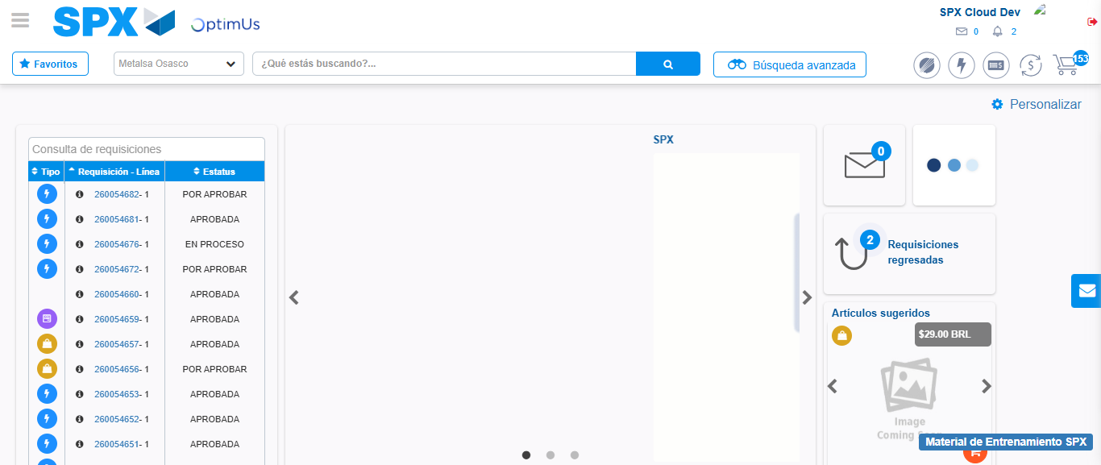Image file-name: QC_Testing-tc002_SPX_Dev5_Crear_Requisicion_Spot_Con_FAD_Tipo_Cobro_CC-1785343166398

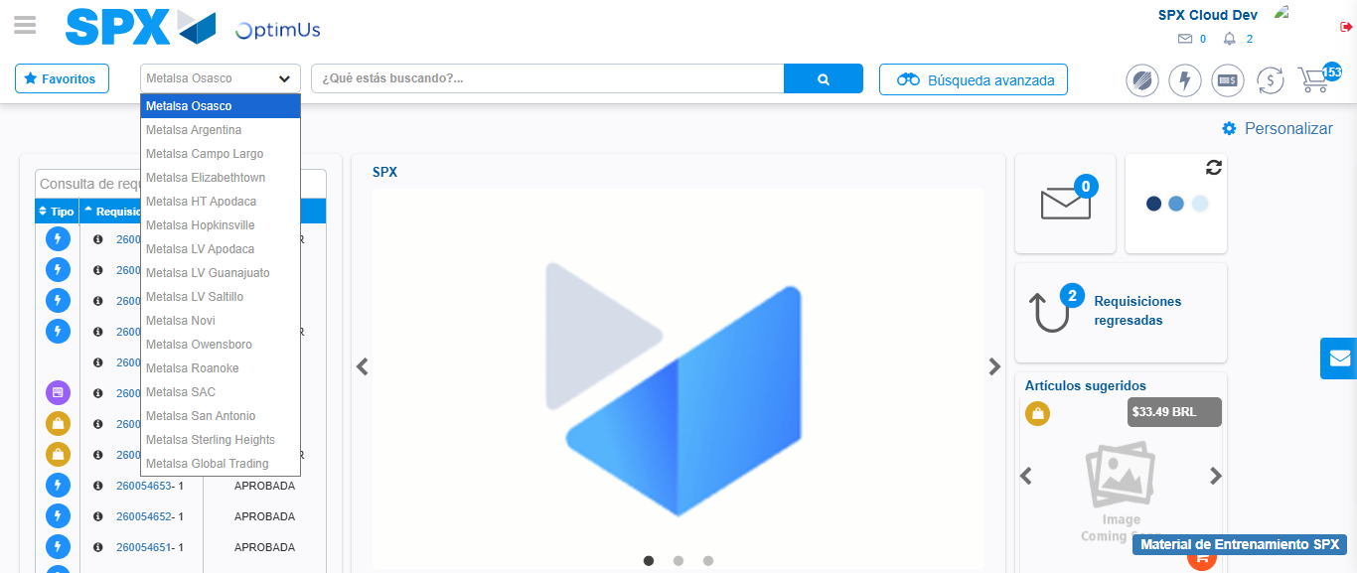Image file-name: QC_Testing-tc002_SPX_Dev5_Crear_Requisicion_Spot_Con_FAD_Tipo_Cobro_CC-1785343169063

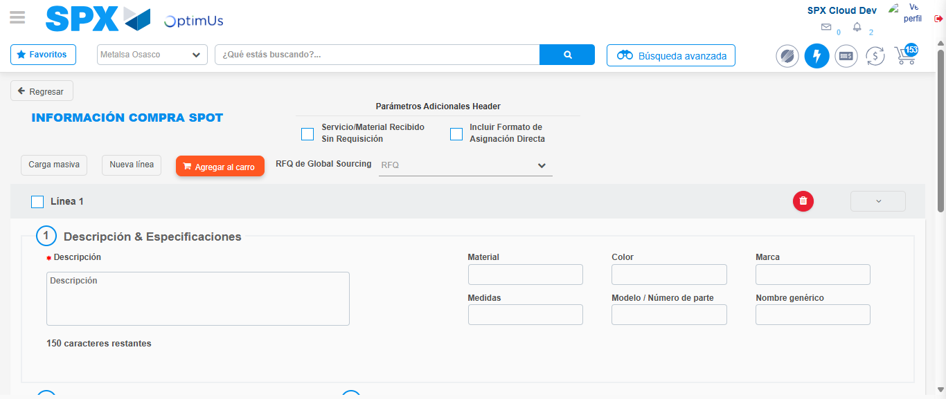Image file-name: QC_Testing-tc002_SPX_Dev5_Crear_Requisicion_Spot_Con_FAD_Tipo_Cobro_CC-1785343189329

Step 3 - Add FAD to Requisition: FAD Successfully Added
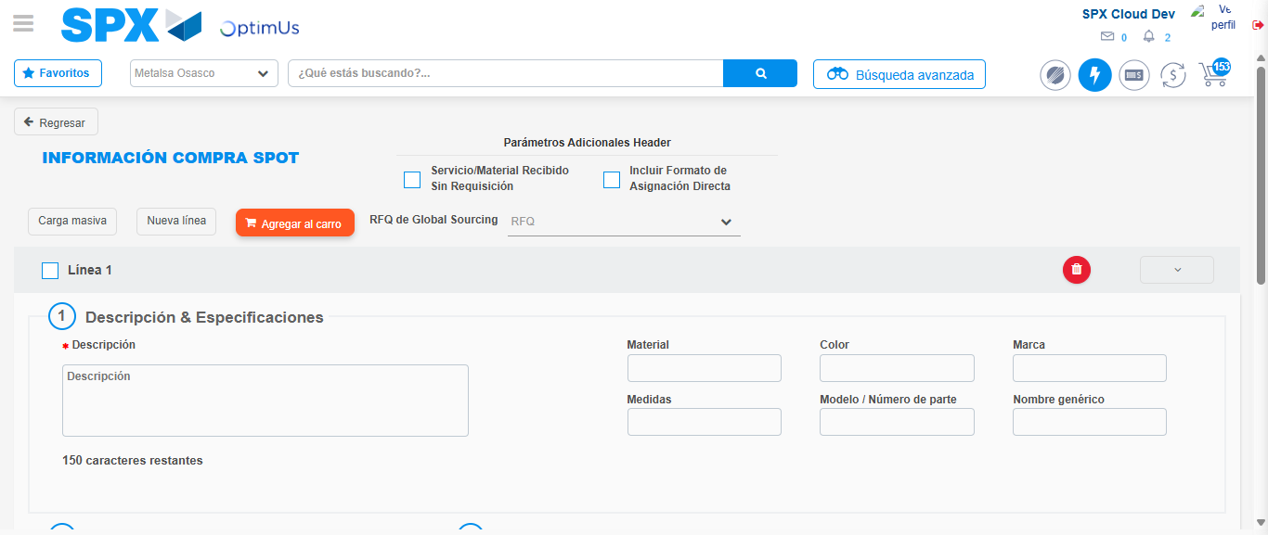Image file-name: QC_Testing-tc002_SPX_Dev5_Crear_Requisicion_Spot_Con_FAD_Tipo_Cobro_CC-1785343189635

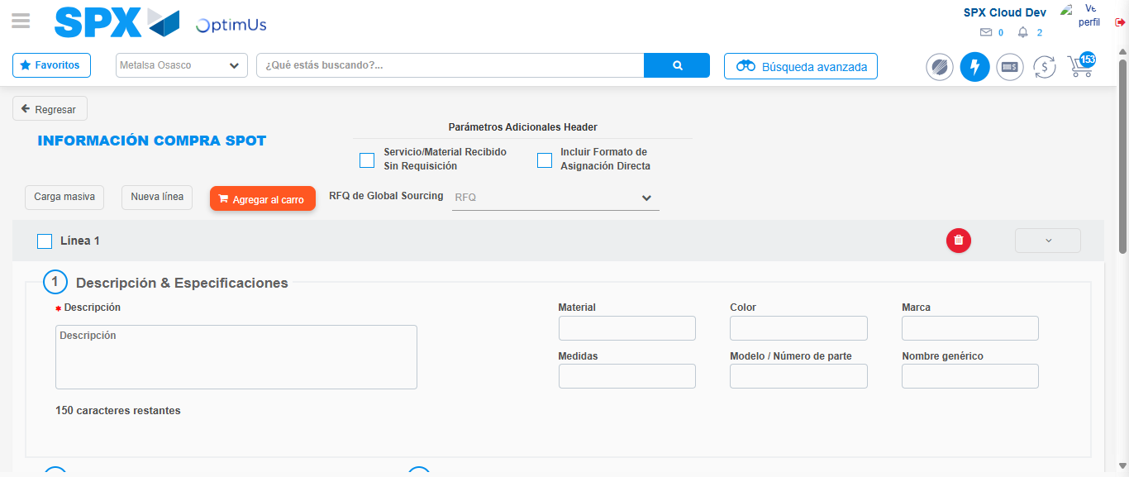Image file-name: QC_Testing-tc002_SPX_Dev5_Crear_Requisicion_Spot_Con_FAD_Tipo_Cobro_CC-1785343189866

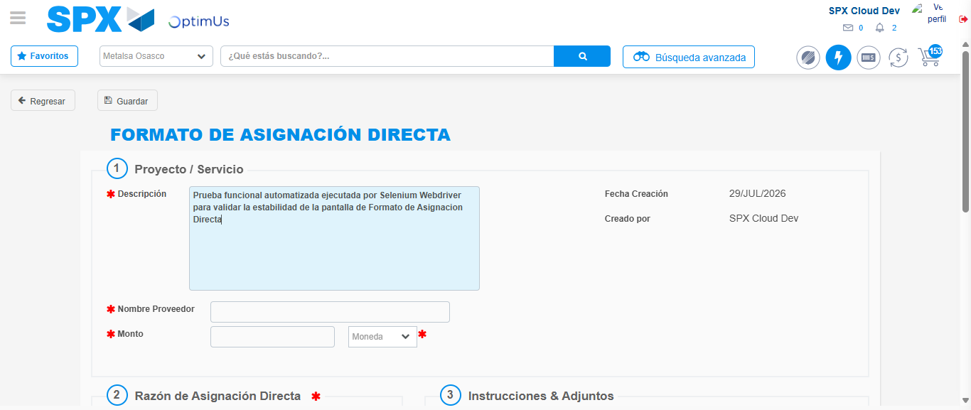Image file-name: QC_Testing-tc002_SPX_Dev5_Crear_Requisicion_Spot_Con_FAD_Tipo_Cobro_CC-1785343192577

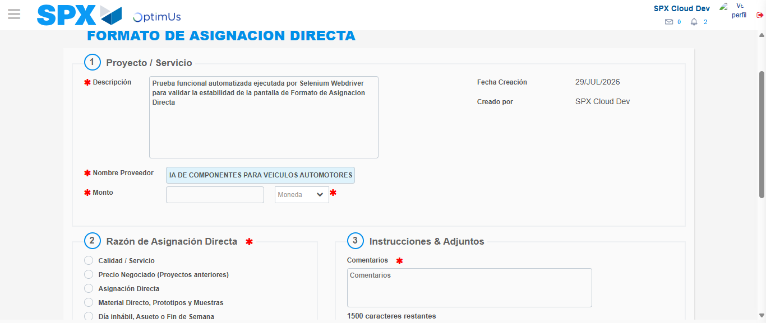Image file-name: QC_Testing-tc002_SPX_Dev5_Crear_Requisicion_Spot_Con_FAD_Tipo_Cobro_CC-1785343201312

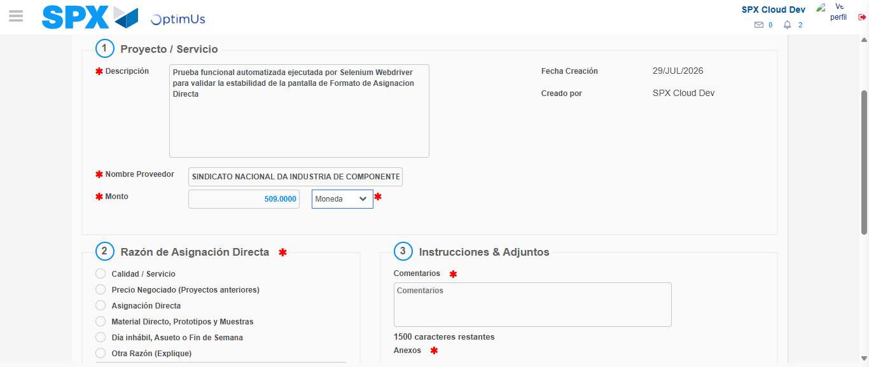Image file-name: QC_Testing-tc002_SPX_Dev5_Crear_Requisicion_Spot_Con_FAD_Tipo_Cobro_CC-1785343201725

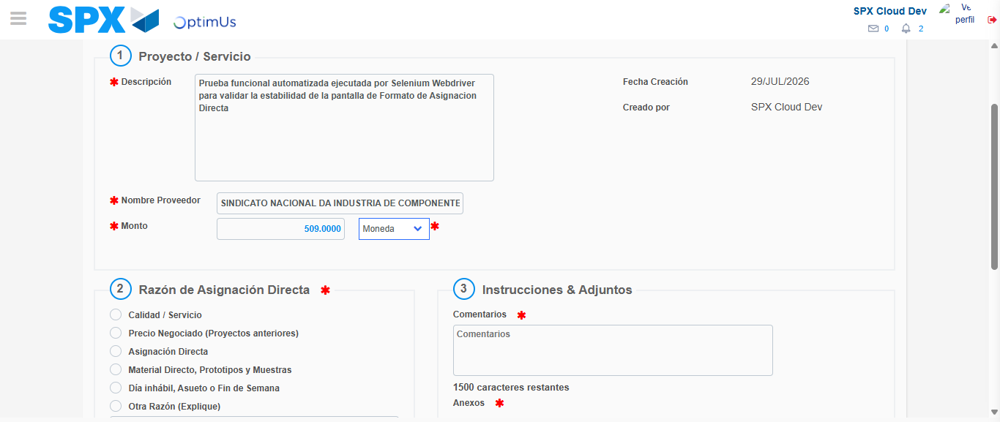Image file-name: QC_Testing-tc002_SPX_Dev5_Crear_Requisicion_Spot_Con_FAD_Tipo_Cobro_CC-1785343201921

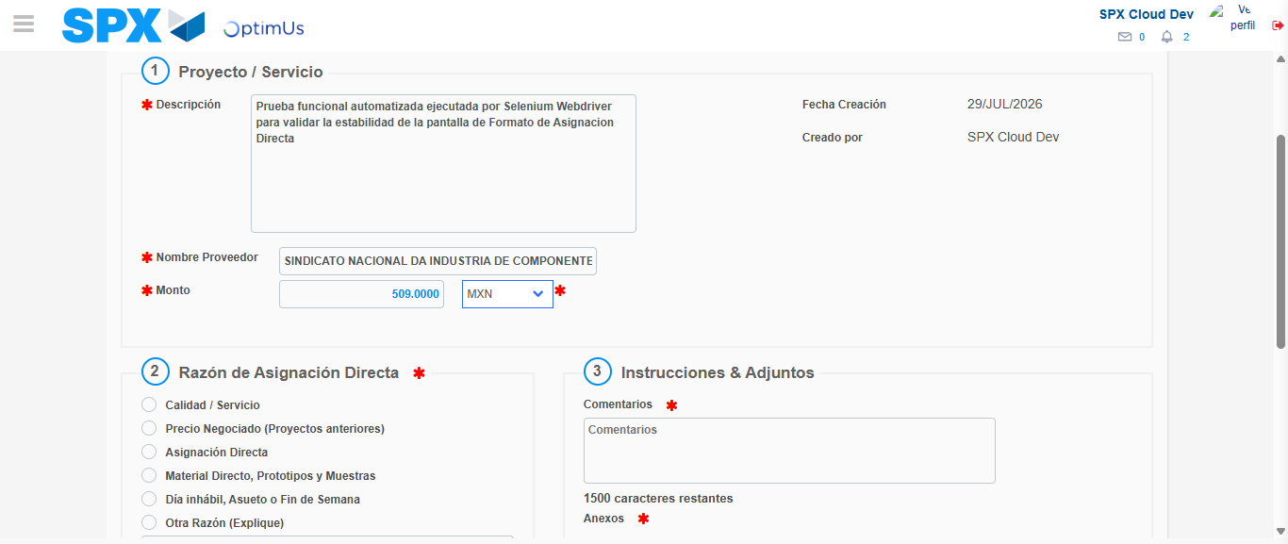Image file-name: QC_Testing-tc002_SPX_Dev5_Crear_Requisicion_Spot_Con_FAD_Tipo_Cobro_CC-1785343202305

Image file-name: QC_Testing-tc002_SPX_Dev5_Crear_Requisicion_Spot_Con_FAD_Tipo_Cobro_CC-1785343202505

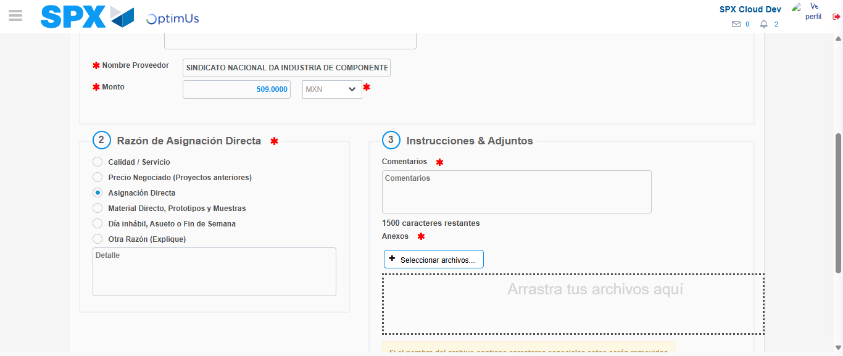Image file-name: QC_Testing-tc002_SPX_Dev5_Crear_Requisicion_Spot_Con_FAD_Tipo_Cobro_CC-1785343203406

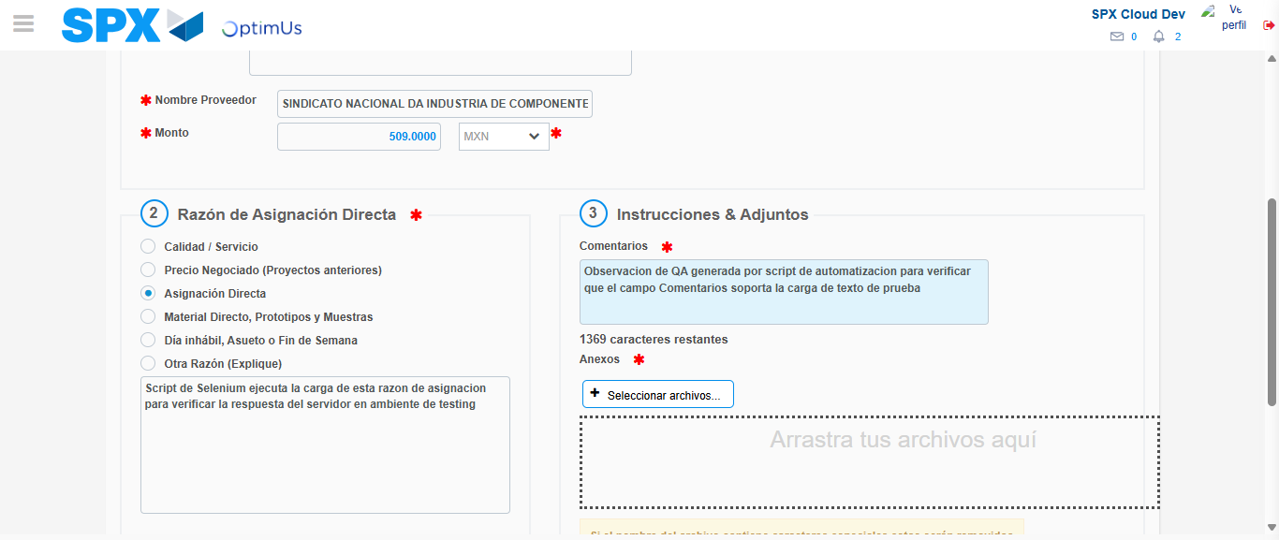Image file-name: QC_Testing-tc002_SPX_Dev5_Crear_Requisicion_Spot_Con_FAD_Tipo_Cobro_CC-1785343214423

Image file-name: QC_Testing-tc002_SPX_Dev5_Crear_Requisicion_Spot_Con_FAD_Tipo_Cobro_CC-1785343215234

Step 4 - Data Capture Spot Buy Requisition: Data captured correctly
Image file-name: QC_Testing-tc002_SPX_Dev5_Crear_Requisicion_Spot_Con_FAD_Tipo_Cobro_CC-1785343189635

Image file-name: QC_Testing-tc002_SPX_Dev5_Crear_Requisicion_Spot_Con_FAD_Tipo_Cobro_CC-1785343189866

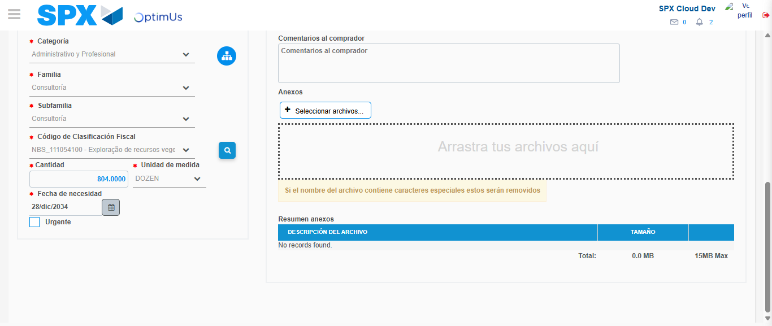Image file-name: QC_Testing-tc002_SPX_Dev5_Crear_Requisicion_Spot_Con_FAD_Tipo_Cobro_CC-1785343230912

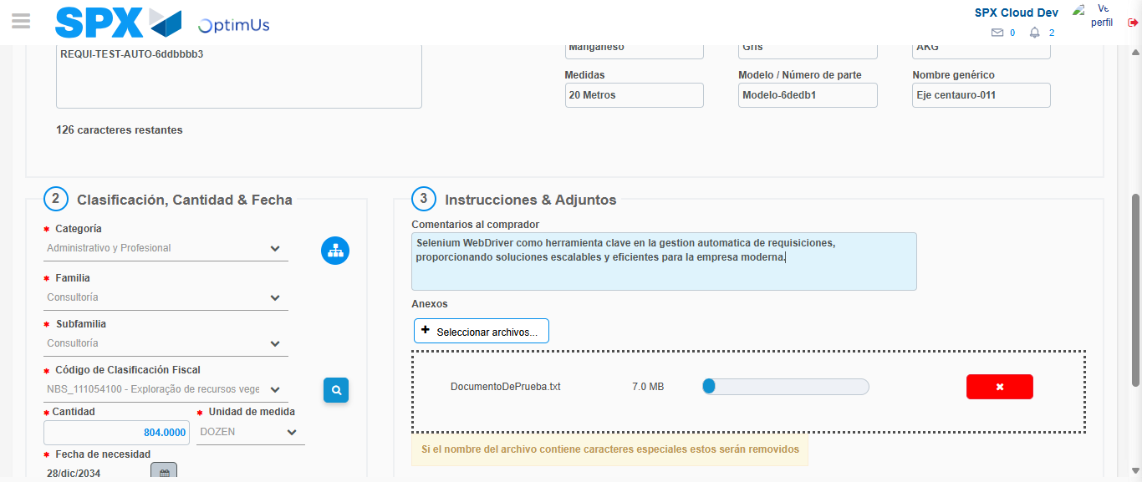Image file-name: QC_Testing-tc002_SPX_Dev5_Crear_Requisicion_Spot_Con_FAD_Tipo_Cobro_CC-1785343231735

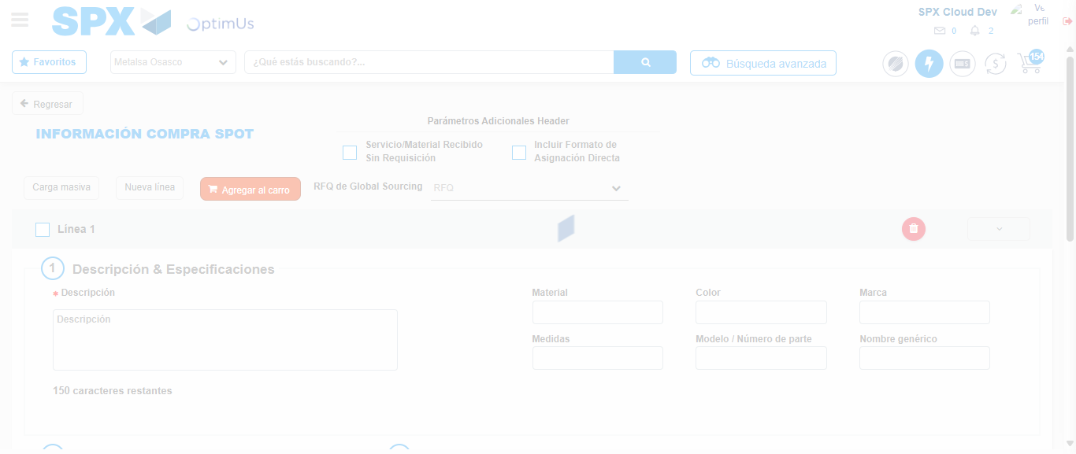Image file-name: QC_Testing-tc002_SPX_Dev5_Crear_Requisicion_Spot_Con_FAD_Tipo_Cobro_CC-1785343237326

Step 8 - Return to Main Page SPX : Return to Main Page SPX
Image file-name: QC_Testing-tc002_SPX_Dev5_Crear_Requisicion_Spot_Con_FAD_Tipo_Cobro_CC-1785343166398

Image file-name: QC_Testing-tc002_SPX_Dev5_Crear_Requisicion_Spot_Con_FAD_Tipo_Cobro_CC-1785343169063

Image file-name: QC_Testing-tc002_SPX_Dev5_Crear_Requisicion_Spot_Con_FAD_Tipo_Cobro_CC-1785343189329

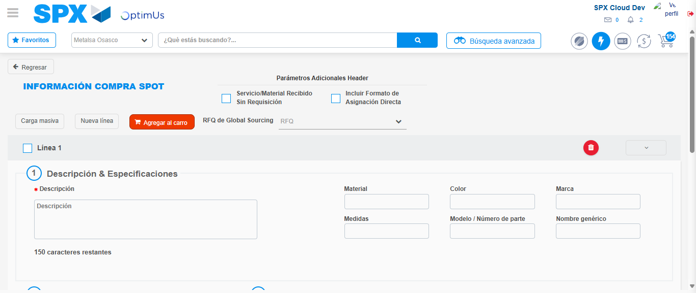Image file-name: QC_Testing-tc002_SPX_Dev5_Crear_Requisicion_Spot_Con_FAD_Tipo_Cobro_CC-1785343239568

Image file-name: QC_Testing-tc002_SPX_Dev5_Crear_Requisicion_Spot_Con_FAD_Tipo_Cobro_CC-1785343239754

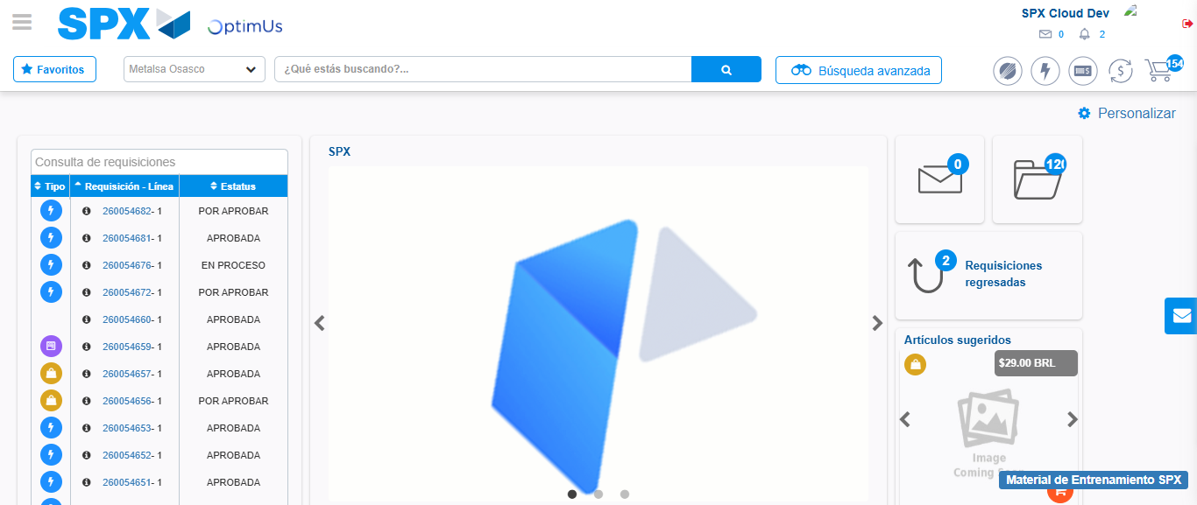Image file-name: QC_Testing-tc002_SPX_Dev5_Crear_Requisicion_Spot_Con_FAD_Tipo_Cobro_CC-1785343260793

Step 9 - Log Out : Log Out SPX
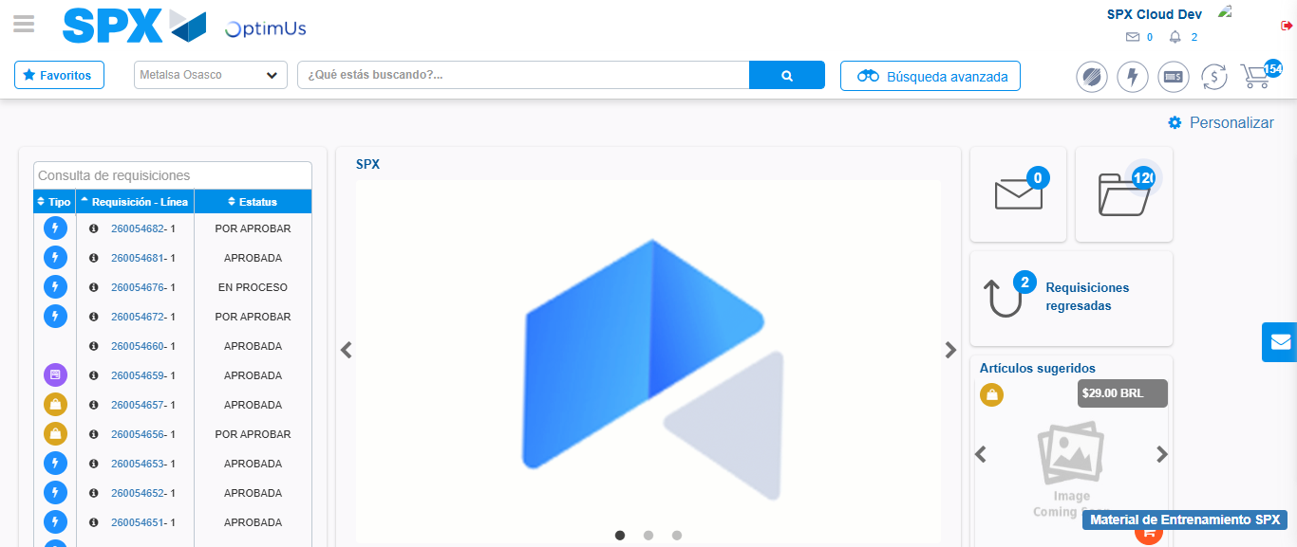Image file-name: QC_Testing-tc002_SPX_Dev5_Crear_Requisicion_Spot_Con_FAD_Tipo_Cobro_CC-1785343261081

